Task 1 — Security Posture Assessment

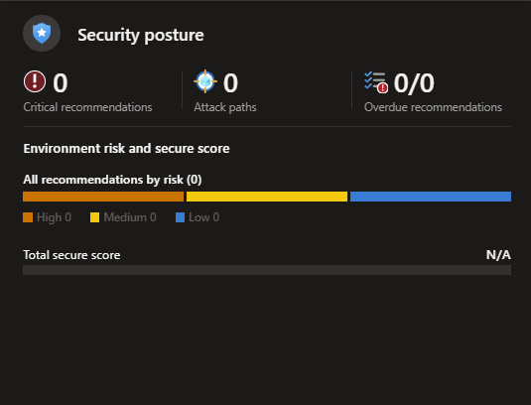
For reasons unknown, my environment isn't displaying a Secure Score. Instead, I'll explain how the security recommendations are prioritized and describe the nature and risk of the most common ones.
How recommendations are prioritized: Recommendations are ranked according to the level of risk they pose to your environment. For example, enabling Privileged Identity Management (PIM) is beneficial, but its absence doesn't make your environment insecure, so it receives a medium priority. In contrast, a compromised user account is rated critical because it represents an immediate and serious threat.
Nature and risk of the most common recommendations: One of the simplest and most effective ways to significantly improve your security posture is by enabling security defaults. This single change implements the following key protections:
- MFA required for all users
- MFA required for admin roles
- Blocking of legacy authentication
Without these controls, user and admin accounts are far more vulnerable to compromise. An attacker only needs to obtain the password to gain full access. Enabling MFA and blocking legacy authentication adds a strong, reliable layer of protection that makes it much harder for malicious actors to succeed.
Remediation:
2a — Close Open Management Ports:
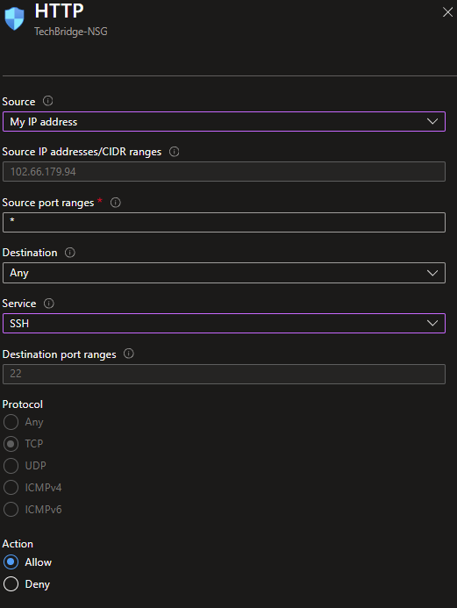
Set the port to deny any incoming traffic. This way no one can access the VM from outside which makes it more secure.

2b — Enable OS Updates:
